|  |  |
| --- | --- |
| **CS217 Object Oriented Programming**  Monday, June 23, 2020  **Course Instructor**  Dr. Danish Shehzad, Dr. Irfan ul Haq  Miss Zain Iqbal,  Mr. Muhammad Haris, Mr. Muhammad Ali | Serial No:  **Final Term Exam**  **Spring Semester 2020**  **Max Time: 3 Hour**  **Max Marks: 80**  **Exam Weight (Out of 100). 40** |

|  |
| --- |
| _____________________ . .  Roll No Section |

**Guidelines for Submission:**

1. You should submit only one PDF document.
2. Write your Roll No on start of each answer.
3. Write the answers on paper and take picture. The figure/image can be pasted inside that document under the appropriate question.
4. Solution file should be saved as “Rollno_Name”.
5. You must submit your solution before due time via Google Classroom. Submissions submitted after the due time shall not be considered.
6. If you don’t finish every part of a question, don’t worry! You can still submit what you’ve done to get marks based on your efforts.
7. In case of copied or plagiarized solutions in exam Or If a student provided help to another student during exam both will be awarded **"F"** grade and it will affect the student CGPA.
8. **Viva** of any student can be conducted by the instructor after conducting an online exam **in case of any doubt.**
9. This document should be submitted through LMS Google Classroom. But in worst case, you can email it within the deadline.
10. Students who will upload the answer sheets as directed containing appropriate answers under the question and follow all the above directions will be give **2 marks.**

|  |  |  |  |  |  |  |  |
| --- | --- | --- | --- | --- | --- | --- | --- |
|  | **Instruction 10** | **Q1** | **Q2** | **Q3** | **Q4** | **Q5** | **Total** |
| **Marks** | **2** | **6*3=18** | **3*6=18** | **12** | **15** | **15** | **80** |
| **Obtained** |  |  |  |  |  |  |  |

**1. Short Questions   [6*3=18]**

I.

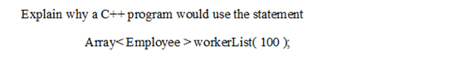

II.

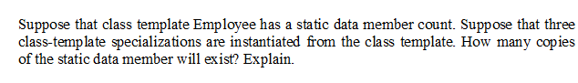

III.

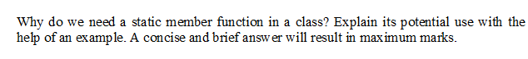

IV.

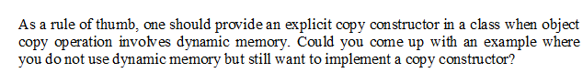

V.



VI.

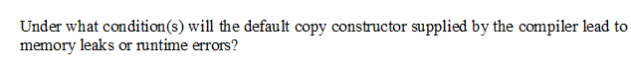

**2. Coding Questions [3*6=18]**

I.

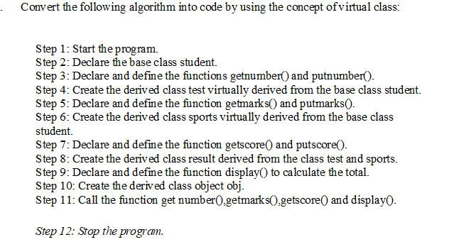

II.

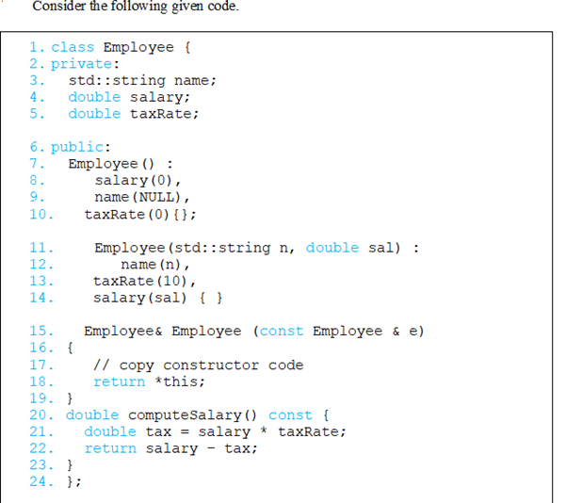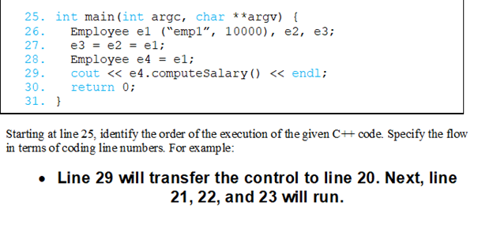

III.

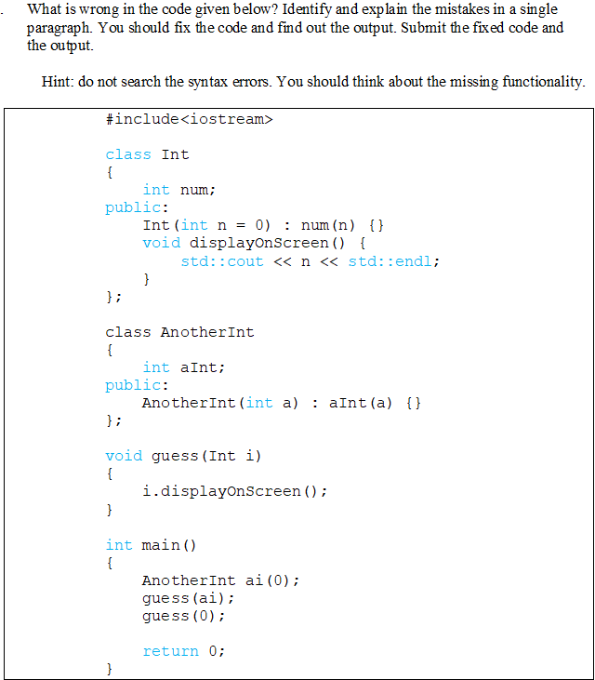

**Long Questions:**

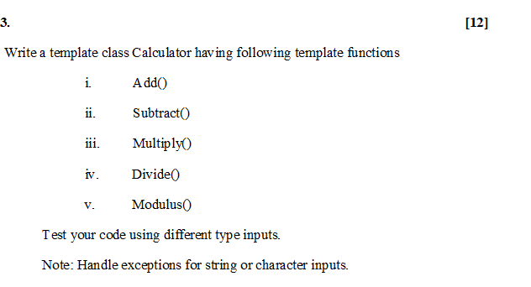

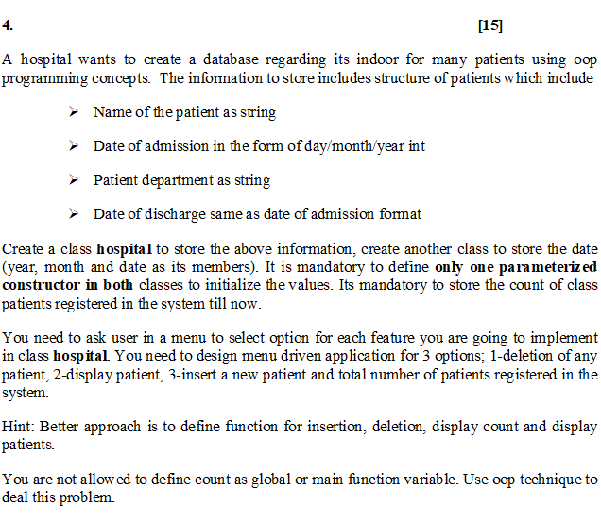

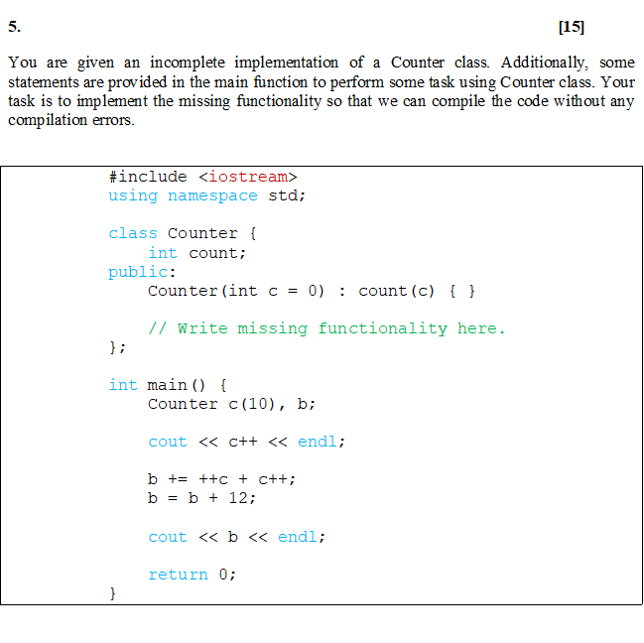

Good Luck ☺